BUILD BEYOND LIMITS, WITH ADDITIVE MANUFACTURING

Manufacture with no limits in scale, shape, or materials, with our integrated Large Format Additive Manufacturing (LFAM) platforms for large scale components.

(Video nển)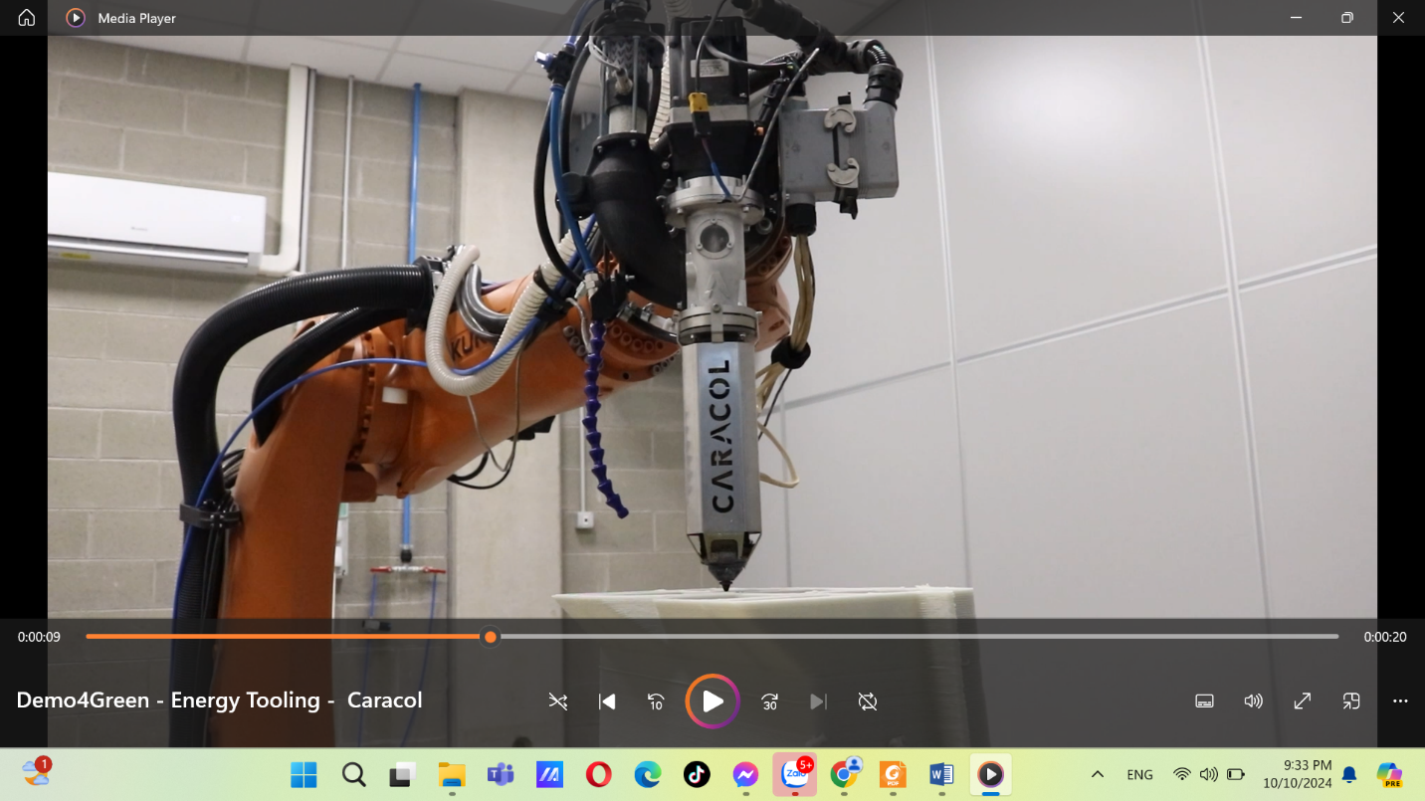

LARGE FORMAT ADDITIVE MANUFACTURING VS TRADITIONAL PROCESS

Producing large and complex components 4 times faster than competition

Weight reduction: up to 70%, approx. 3 times better than competition

Waste reduction: up to 70%, approx. 3 times better than competition

Cost saving: up to 70%, approx. 3 times better than competition

The CAPEX (capital expenditure) of the initial unit is 50% of competition.

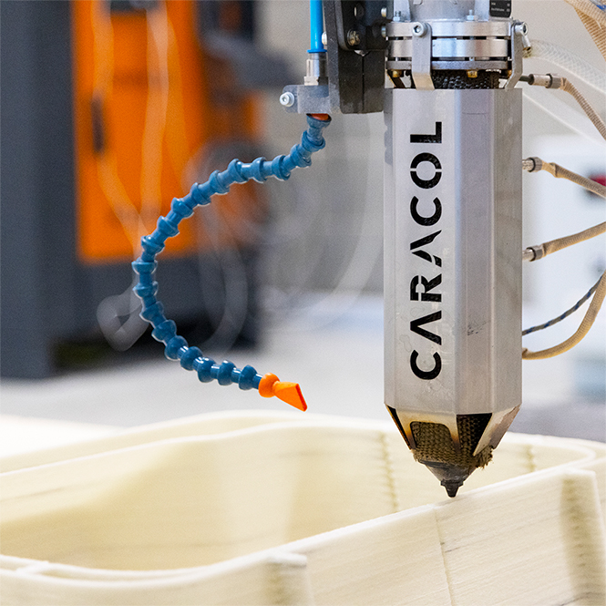

HERON AM PLATFORM

Modularly configured Heron AM, to fit your industrial manufacturing needs with no limits in scale, shape, and material.

E**xtruders process composite fiber-reinforced thermoplastic pellets.**

Robotic arms leverage the flexibility of the 6+ axes movements.

**Our partner, Caracol,** developed its **software platform Eidos Manufacturing**.

The printing bed is an **aluminum frame structure with interchangeable top panels** to fit all needs, customizable in terms of size.

An automated feeding system ensures the direct and continuous supply of material.

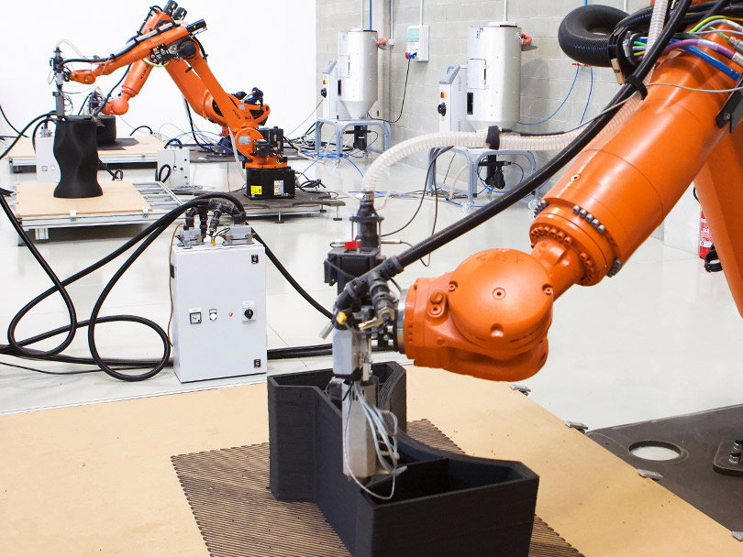

Now what can we print BIG for you?

### ***If you need a prototype or mold for your aerospace, automotive, or marine project***

Welcome to write us at info@in3d.info

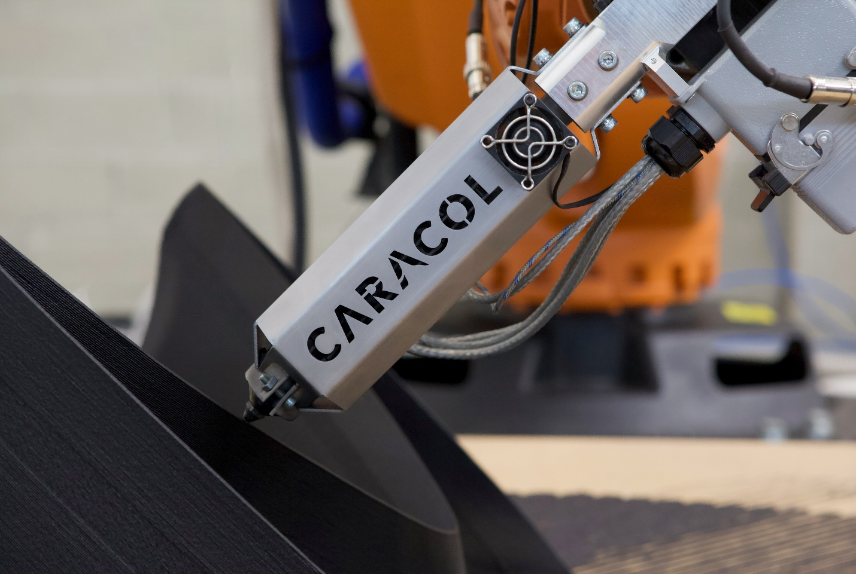

The**High Accuracy (HA) extruder**is lightweight and compact**to achieve agility, quality finishing, and precision.**

The **High Versatility (HV) extruder** **flexibly adapts to diverse industrial needs and** a broad range of **applications**.

The**High Flow (HF) extruder drastically reduces print times.** With its robust structure, high throughput, and temperatures, it processes an extensive range of materials **maintaining high print quality and efficient deposition.**

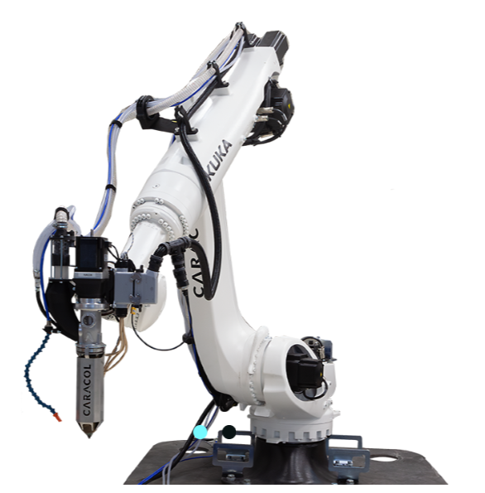

Leveraging the flexibility of the 6+ axes movements, robotic arms allow Heron AM to manufacture parts with very complex geometries, including non-planar tool paths, and unconventional slicing at different angles such as 45° or 60.

Furthermore, arms can be extended on the x-axis with a rail or on the y-axis adding a plinth.

To provide the best automation solution, Heron AM can be setup with robots from KUKA to FANUC and ABB.

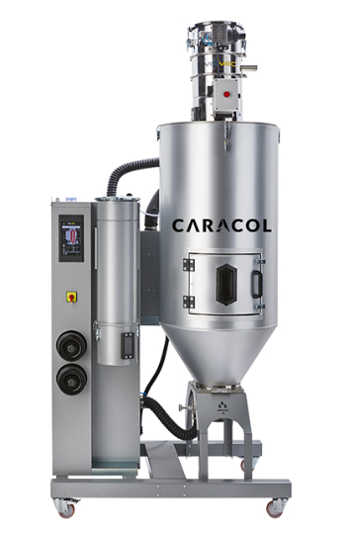

**The direct and continuous supply of material** is possible thanks to the **automated material feeding system. A drying unit** is connected to the extruder to input pellets during the whole printing cycle, avoiding manual operations that could stop the machine’s job.

Pellets and shreds are stored at the right humidity and temperature and dried for **best performance and quality**. Its capacity of 50-80 Kg (110-176 lb) can be extended with direct connection to a bigger storage or with multiple material feeding units, to facilitate production-continuity for unlimited hours.

Cost-Effective Large Format Additive Manufacturing Solution

Eight Sectors for LFAM Technology

We deliver the best qualified LFAM solution to eight independent global sectors, each critically in need of reducing costs and carbon emissions.

(Hình ảnh thay đổi sau)

|  |  |  |  |
| --- | --- | --- | --- |
| Aerospace | Architecture & Construction | Automotive | Design & Furniture |
| Key benefits:  Quality first  Weight reduction  Short lead time | Key benefits:  Geometric complexity  Bio-based & recycled materials  Reduced carbon emissions | Key benefits:  Weight reduction  Part consolidation  Short lead time | Key benefits:  Design freedom  Custom-made  Innovative materials |

(Hình ảnh thay đổi sau)

|  |  |  |  |
| --- | --- | --- | --- |
| Energy | Marine | Railways | Tooling |
| Key benefits:  Part optimization  Short lead time  Specialized materials | Key benefits:  Flexible production  Short lead time  Specialized materials | Key benefits:  Minimized vehicle downtime  High-performance materials  Flexible production | Key benefits:  High-temperature materials  Optimized resource use  Long-life agility and versatility |

SUCCESS STORIES

|  |  |  |
| --- | --- | --- |
| D:\AS\New Business 2024\2. Suppliers\Caracol\Photos - Unclassified\Aerospace trim and drill mold - PC with CF.jpg | D:\AS\New Business 2024\2. Suppliers\Caracol\02. Media\Photos\Caracol Projects\Art and Entertainment\SPORT EQUIPMENT 02.png | D:\AS\New Business 2024\2. Suppliers\Caracol\02. Media\Photos\Caracol Projects\Tooling\Caracol x Connova 02.png |
| Aerospace trim and drill mold  System: Heron 400, HF Extruder, 12 mm Nozzle  Materials: PC with carbon fibers  Post processing: machining  Print time: 10 hours  Weight: 120 kg | Ipad holder equipment  System: Heron 200, HA Extruder, 03 mm Nozzle  Materials: PP with glass fibers  Post processing: machining  Print time: 06 hours  Weight: 15 kg | Aerospace tool for autoclave lamination for a drone nose  System: Heron 400, HF Extruder, 12 mm Nozzle  Materials: DAHLTRAM C-250 CF  Post processing: machining and resin  Print time: 15 hours  Weight: 130 kg |

|  |  |  |
| --- | --- | --- |
| D:\AS\New Business 2024\2. Suppliers\Caracol\Photos - Unclassified\Decor item - recycled PETG with GF.jpg | D:\AS\New Business 2024\2. Suppliers\Caracol\02. Media\Photos\Caracol Projects\Marine\MARINE_Yacht Airgrids 01.jpg | D:\AS\New Business 2024\2. Suppliers\Caracol\Photos - Unclassified\Top cover part of yacht - ABS with GF.jpg |
| Decorative item  System: Heron 300, HA Extruder, 05 mm Nozzle  Materials: recycled PETG with glass fibers  Post processing: machining  Print time: 10 hours  Weight: 20 kg | Ventilation air grid of yacht  System: Heron 300, HA Extruder, 03 mm Nozzle  Materials: ABS 30% with glass fibers  Post processing: sanding, gel coating, and painting  Print time: 20 hours  Weight: 22 kg | Top cover part of yacht  System: Heron 300, HA Extruder, 03 mm Nozzle  Materials: ABS 30% with glass fibers  Post processing: sanding, gel coating, and painting  Print time: 40 hours  Weight: 48 kg |

|  |  |
| --- | --- |
| D:\AS\New Business 2024\2. Suppliers\Caracol\02. Media\Photos\Caracol Projects\Aerospace\Caracol - Tank Metallo - D-Orbit - TechFast - Print 01.png | WAAM PLATFORM (launching soon)  Direct Energy Deposition (DED) – Wire Arc welding Additive Manufacturing (WAAM)  In WAAM, the thermal energy of an electric arc is employed to melt electrodes and deposit layers of material for the formation of walls or for the simultaneous coating of two materials. A torch connected to a robot is used to melt the wire feedstock. |
| * Low initial costs * Faster production speed * Large sizes | * Weight reduction: up to 50% * Waste reduction: up to 70% * Cost saving: up to 70% |

Why in 3D?

|  |  |
| --- | --- |
| D:\AS\New Business 2024\Website\in3D.info\Caracol-Heron-AM.jpg | * PROFIT -> generate profit due to cost savings from weight and waste reduction. * HYBRID -> unique triple of robotics – 3D printers – CNC machines hybrid sharing structure. * NO SCALE LIMITS -> easily upgraded up to 20 meters in length with a rail or plinth system. * EIDOS -> software platform for integrated services from parameters and path planning to monitoring and control during production. * PRODUCTIVITY -> deliver 4 times higher output than any other machines. |

F.A.Q.

1. What is Additive manufacturing process?

Additive Manufacturing, commonly known as 3D printing, is a transformative process that builds objects layer by layer, through the deposition of a variety of materials including plastics, metals, ceramics, and even biomaterials on a digital 3D model. This innovative technology stands in contrast to traditional subtractive manufacturing, offering unparalleled design freedom and efficiency to produce lighter, stronger parts and systems used across a variety of industries.

1. How does Additive Manufacturing differentiate from other technologies?

Additive Manufacturing (AM) stands apart from traditional manufacturing methods due to its revolutionary approach. Unlike subtractive manufacturing that involves cutting away material from a solid block, AM constructs objects layer by layer using digital designs. Thanks to Additive Manufacturing technology, it is possible to create complex geometries and intricate designs with utmost precision by cutting waste and lead time through an environmentally friendly and cost-efficient process.

1. How many Additive Manufacturing types exist?

Additive Manufacturing encompasses a diverse array of techniques, each of them tailored to specific materials and application, offering unique advantages and targeting specific precision requirements and industry needs. While new techniques may emerge, currently several prominent Additive Manufacturing technologies are applied to industrial contexts. Just to cite a few: Fused Deposition Modeling (FDM), Stereolithography (SLA), Selective Laser Sintering (SLS), Binder Jetting, Direct Metal Laser Sintering (DMLS).

1. What are the main benefits of Additive Manufacturing?

Additive Manufacturing offers a multitude of compelling advantages across industries. Some key benefits include design freedom; rapid prototyping and iteration; high customization; use of wide variety of materials; waste reduction; shorter lead time and cost-reduction, also for low volume production; supply chain efficiency and sustainability. Its potential to reshape manufacturing through innovation, efficiency, and sustainability is remarkable.

1. Why choosing LFAM solutions to produce parts?

Opting for Large Format Additive Manufacturing solutions means transforming the way parts are created, providing substantial benefits across industries. The compelling advantages of LFAM technology for the production of lighter yet robust components are: scalability, design flexibility, higher customization, reduced waste, faster and cost-efficient production, reduced tooling costs, no need of complex assembly, supply chain optimization, and innovative applications.

1. Which are the main industries using LFAM technology?

LFAM (Large Format Additive Manufacturing) technology is applied on several advanced industries that are revolutionizing the way products are designed, manufactured, and utilized. The main sectors harnessing LFAM’s capabilities are aerospace, defence, automotive, marine, railway, architecture and construction, furniture and design consumer goods, energy and renewables, arts and entertainment, research and academia. Enabling innovative designs and contributing to overall efficiency, LFAM’s influence is likely to expand further, opening new avenues for applications and growth.

IN 3D

Empowering Responsible Manufacturing

|  |  |
| --- | --- |
| In 3D: Resilient, Efficient Robotics, 3D Printing, and CNC Platforms | Get in touch with us! |
| In 3D partnering with Caracol creates a resilient, cost-effective hybrid manufacturing platform. With streamlined processes for manufacturing, installation, and maintenance, In 3D offers lower costs and competitive TCO values, challenging existing 3D printing solutions and traditional processes. | * Office email:   [info@in3d.info](mailto:info@in3d.info)   * Hotline:   (84) 836 166 255   * Office location:   Hancorp Plaza, 72 Tran Dang Ninh Street, Cau Giay District, Ha Noi City, Vietnam |